**Topic 3: Discrete and Continuous Probability Distributions Solutions**

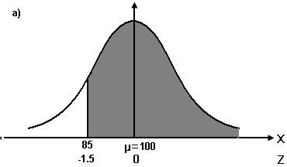**Q11**

*X ~ N(100, 102)*

a) P(X > 85) = P (Z > )

= P (Z > -1.5)

= 1 - P (Z <= -1.5)

= 1 – 0.0668

= 0.9332

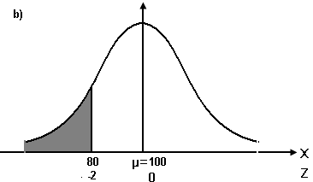b) P(X < 80) = P (Z < )

= P (Z < -2)

= 0.0228

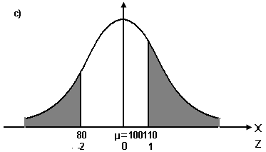c) P(X < 80 or X > 110) = P (Z < ) + P (Z > )

= P (Z < -2) + P (Z > 1)

= 0.0228 + 1 – P (Z <= 1)

= 0.0228 + 1 – 0.8413

= 0.1815

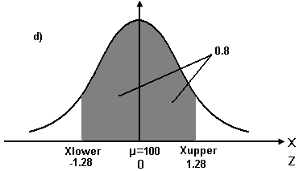d) P (Xlower < X < Xupper) = 0.8



P(Z < -1.28) = 0.10 and P (Z < 1.28) = 0.90

Z =  = -1.28 and Z =  = 1.28

Xlower = -1.28 (10) + 100 = 87.2 and Xupper = 1.28 (10) + 100 = 112.8

**Q12**

Let X be the breaking strength of plastic bags.

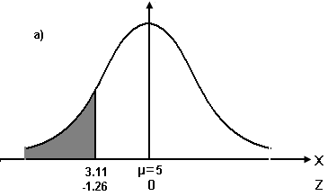*X ~ N(5, 1.52)*

a) P (X < 3.11) = P (Z < )

= P (Z < -1.26)

= 0.1038

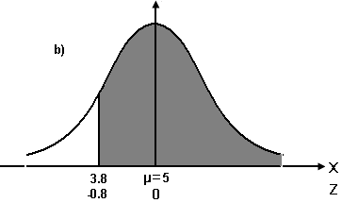b) P (X >= 3.8) = P (Z >= )

= P (Z >= -0.8)

= 1 – P (Z < -0.8)

= 1 – 0.2119

= 0.7881

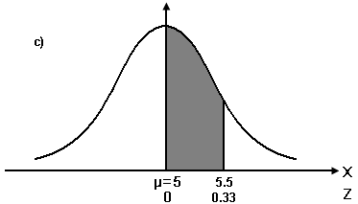c) P (5 < X < 5.5) = P ( < Z < )

= P (0 < Z < 0.33)

= 0.6293 – 0.5

= 0.1293

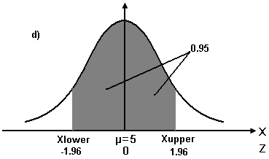d) P (Xlower < X < Xupper) = 0.95



P (Z < -1.96) = 0.025 and P (Z < 1.96) = 0.975

Z =  = -1.96 Z =  = 1.96

Xlower = -1.96 (1.5) + 5 = 2.06 Xupper = 1.96 (1.5) + 5 = 7.94

**Q13**

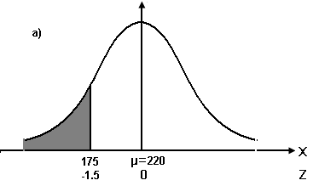Let X be the length of long-distance telephone call.

*X ~ N(220, 302)*

1. P (X < 175) = P (Z < )

= P (Z < -1.5)

= 0.0668

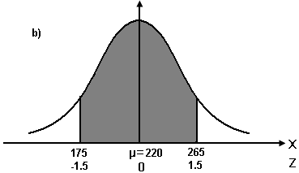

1. P (175 < X < 265) = P (< Z < )

= P (-1.5 < Z < 1.5)

= 0.9332 – 0.0668

= 0.8664

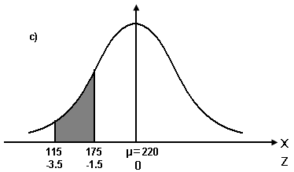c) P (115 < X < 175) = P (< Z < )

= P (-3.5 < Z < -1.5)

= 0.0668 – 0.00023

= 0.06657

d) Let A be the length of a call if only 1 % of all calls are shorted

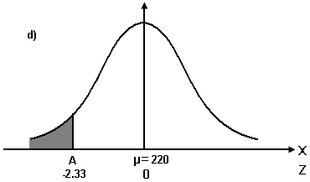P (X < A) = 0.01

Since P (Z<-2.33) = 0.01

 = -2.33

A = -2.33 (30) + 220 = 150.1

**Q14**

a) Let X be the exam marks of the student

2)

 

  

 

 

By solving equation (1) & (2)





Sub into (2)



b) =  =  = 0.7123

**Q15**

a) 

= == 0.0228 (2.28%)

The proportion of the bottles is subject to penalty by the Customer Council is 0.0228.

b)  =  = 0.0082 (0.82%)

The proportion of the bottles is risking to excess spilling upon opening is 0.0082.

1. P(x < 1.9) = 1 - 0.99

 $$\operatorname{Pr}\left(Z<\frac{1.9-μ}{0.05}\right)=0.01$$

= -2.33

 = 2.0165

**Q16**

a) The loading time is normally distributed with mean of 3 seconds

Most likely: 2.9-3.1, since it lies in the central part of the normal distribution model, which has the largest area, thus the largest probability to occur.

Less likely: 3.5-3.7, since it is the farthest interval from the mean, thus has the least probability to occur under the normal distribution model.

b) P(exactly 2) = 0, since it is a line, not an area, this probability = 0

**Q17**

Let x be the volume that should be stamped on the bottle:

P(X<x) = 0.03

P(Z<)=0.03

=-1.88

x= 985.6